Task 1

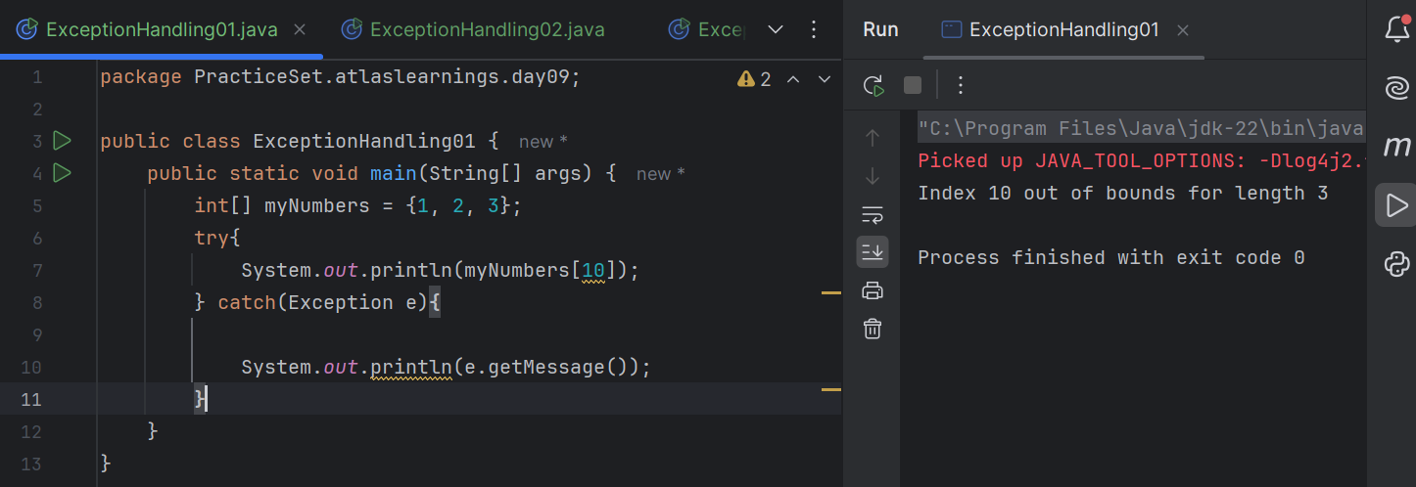

Task 2

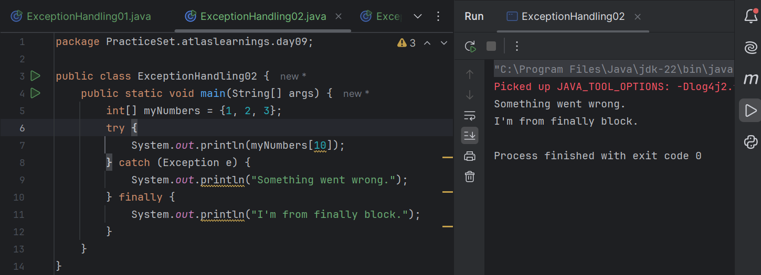Task 3

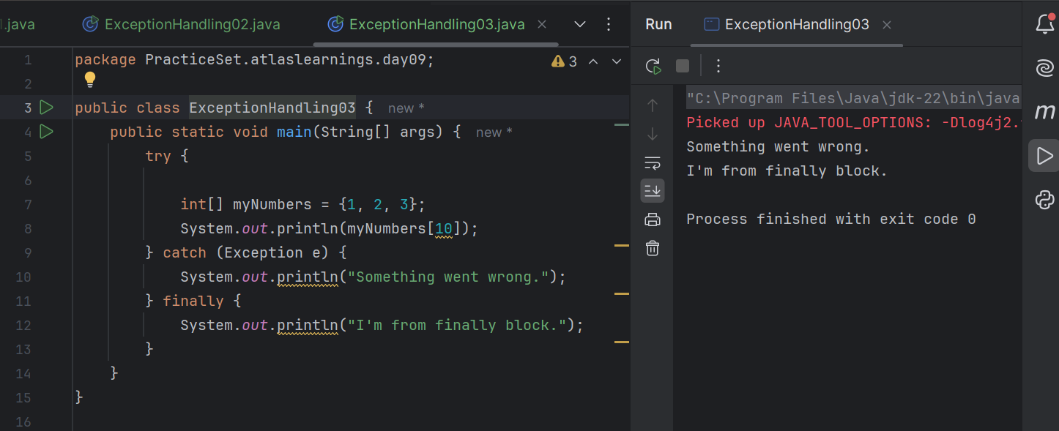

Task 4

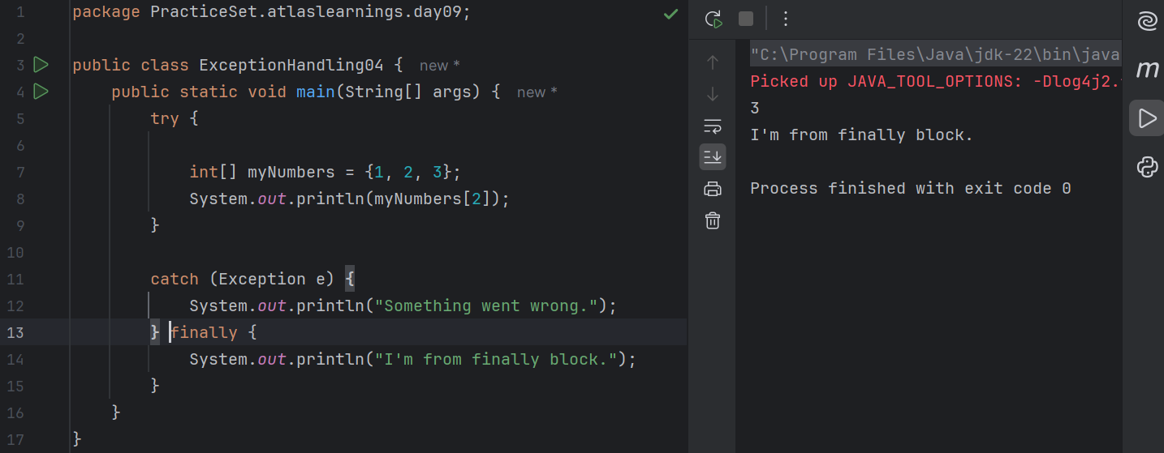

Task 5

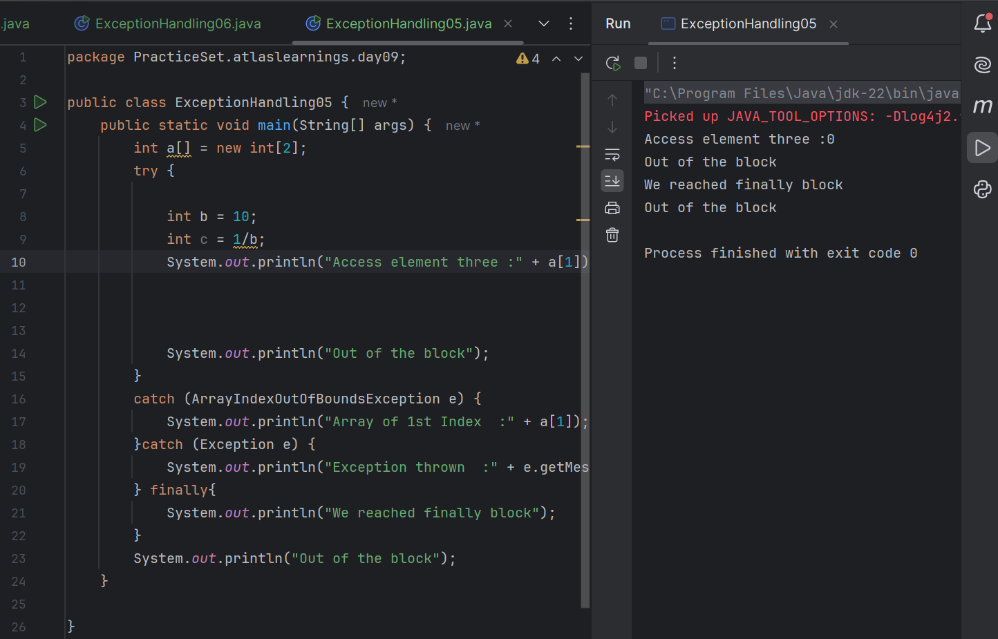

Task 6

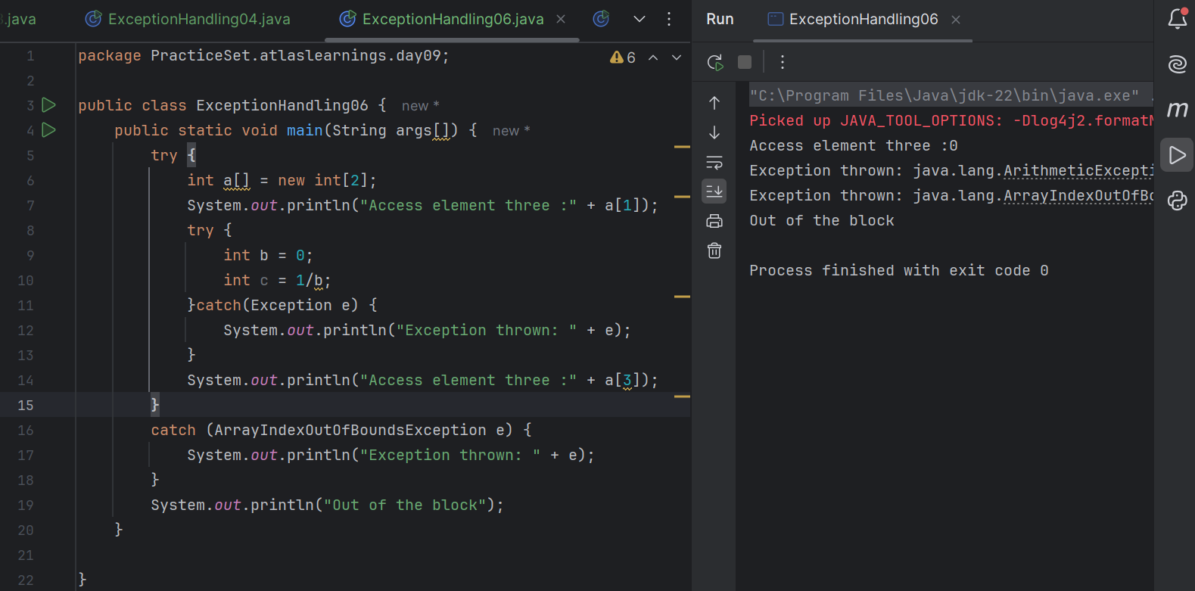

Task 7

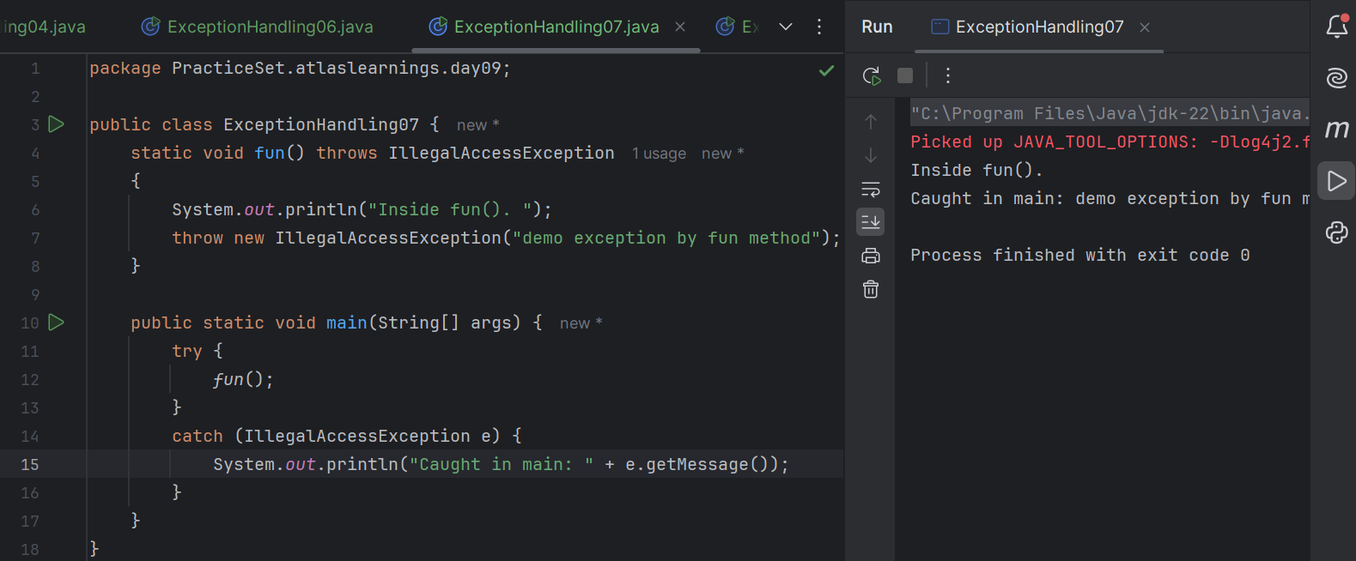

Task 8

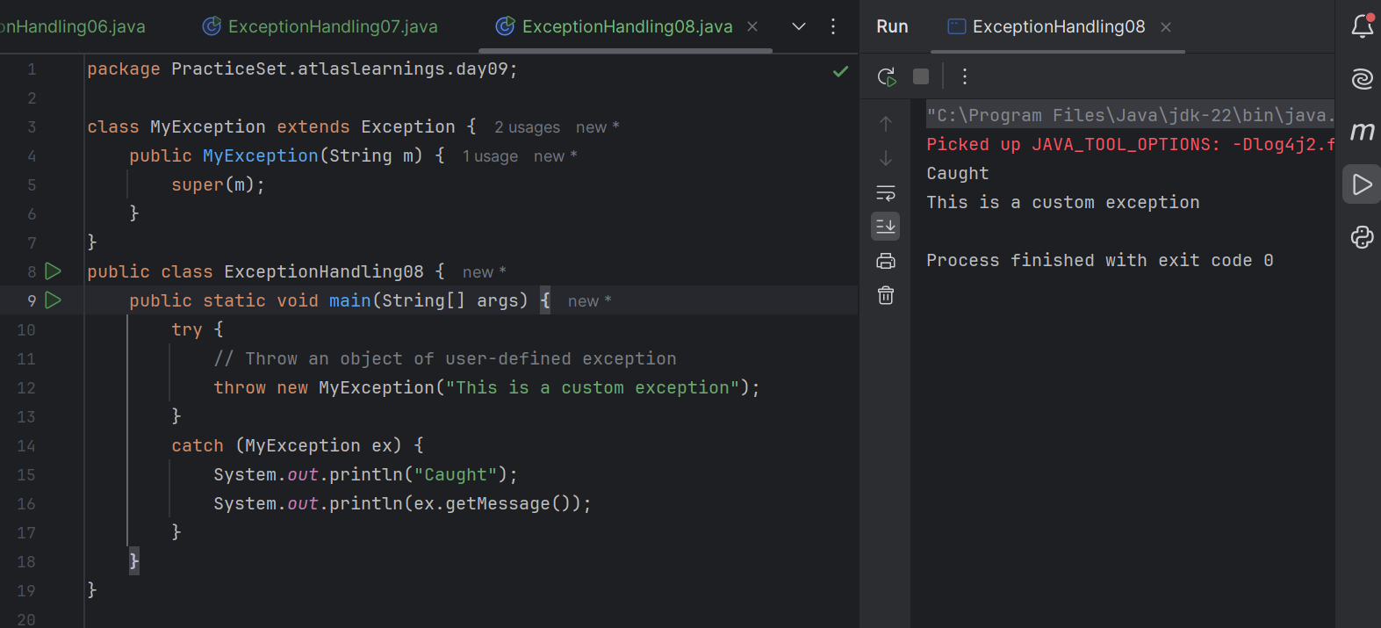

Task 9

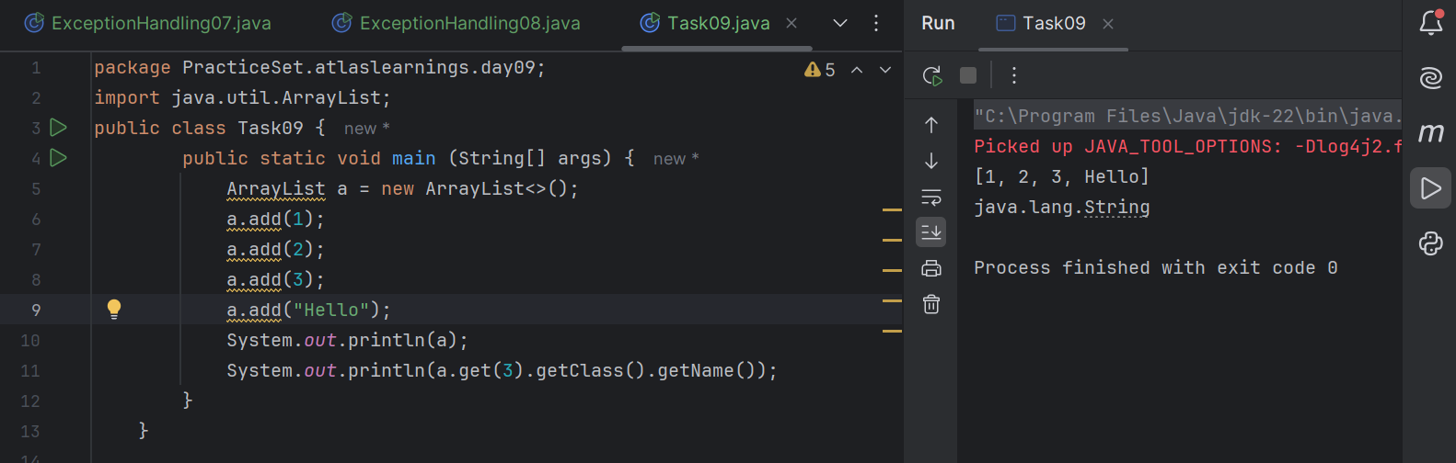

Task 10

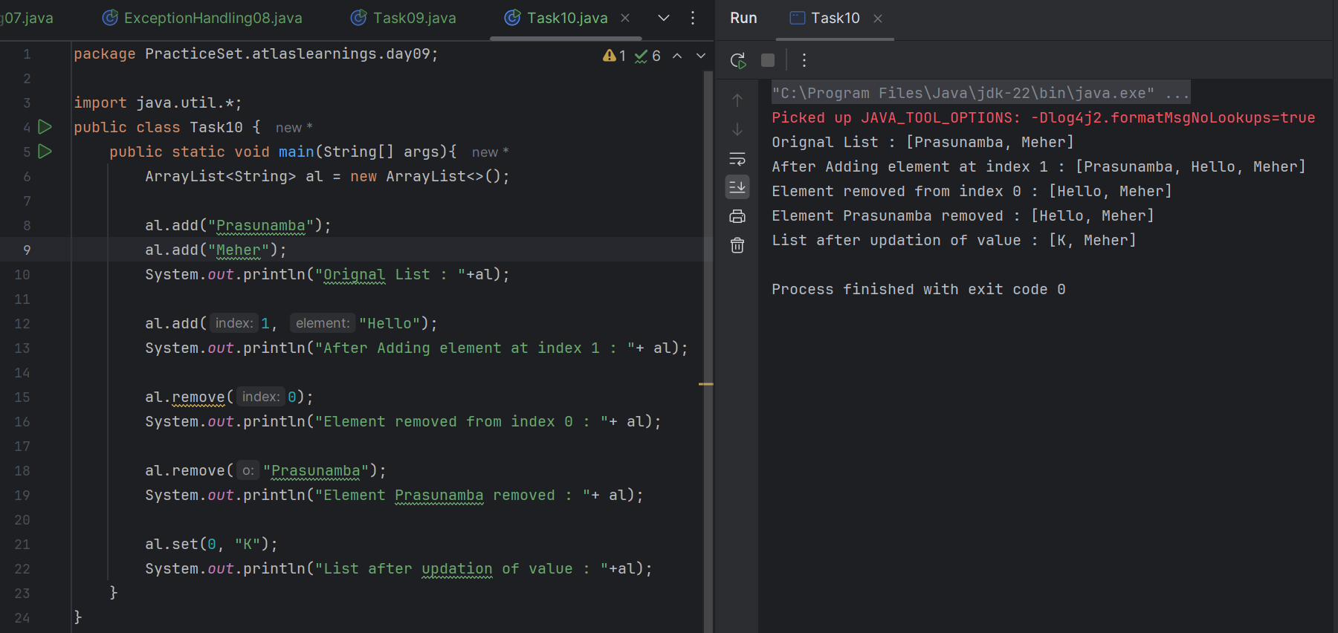

Task 11

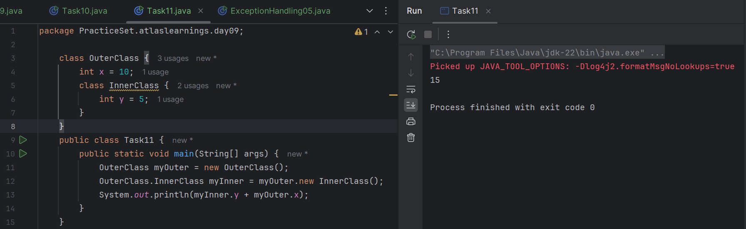

Task 12

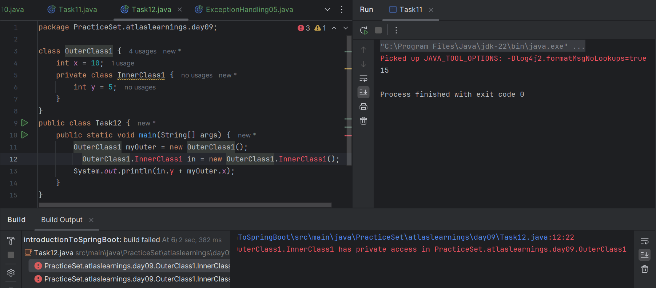

Private classes cannot be accessed outside.

Task 13

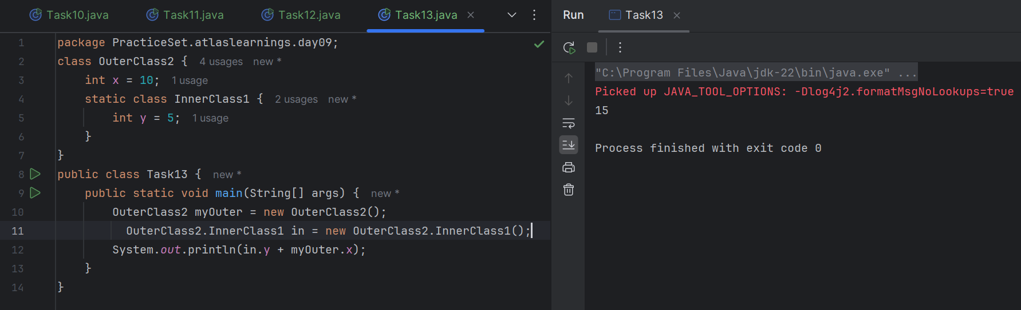

Task 14

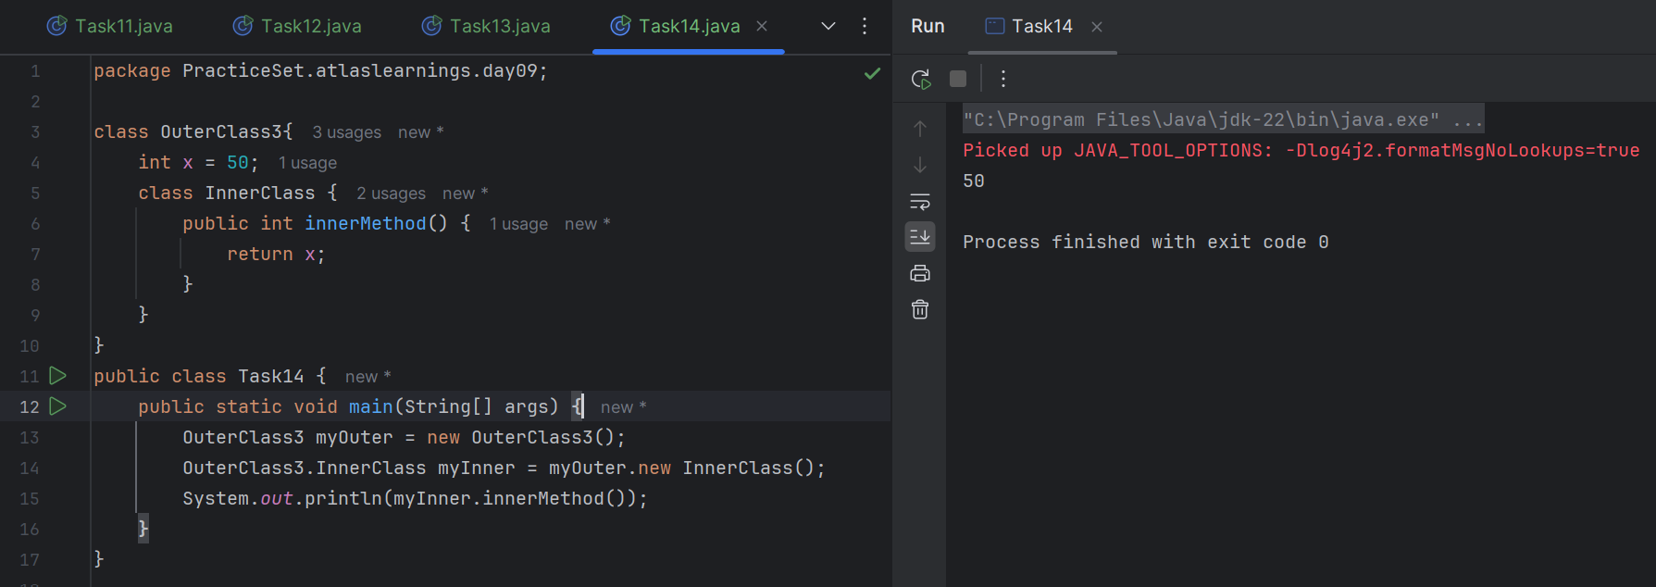

Task 15

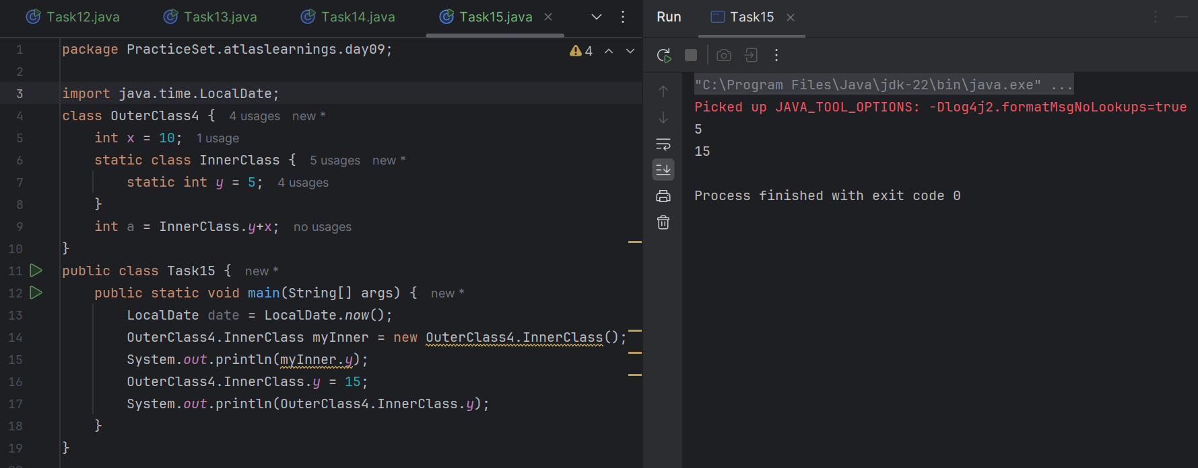

Task 16

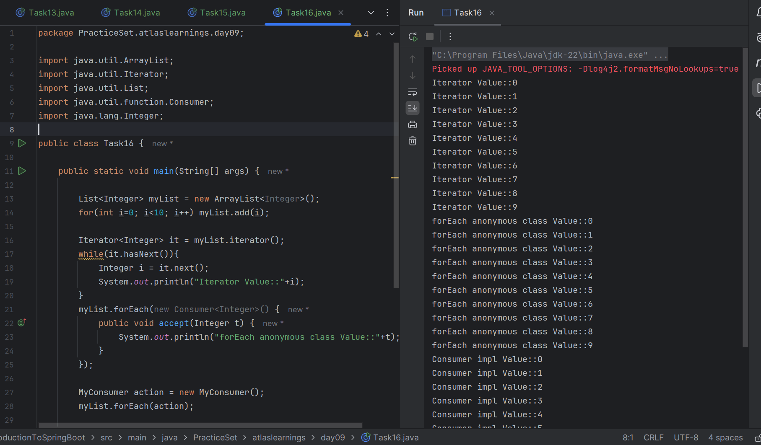

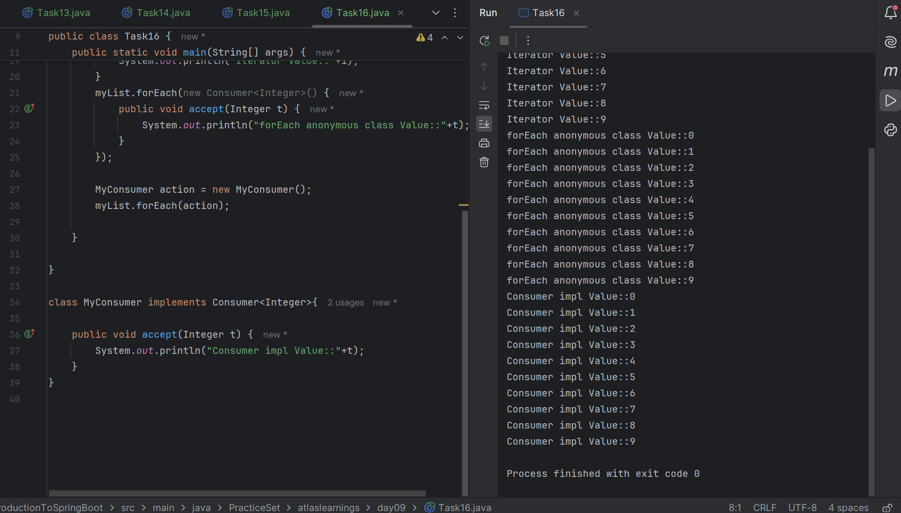

Task 17

What are the features of Java 8

1. Lambda Expressions

Now we can use shorthand for writing some programs

(a, b) -> a + b

1. Default Method in Interface

Interfaces can have method implementations using the default keyword.

interface MyInterface {

default void show() {

System.out.println("Default implementation");

}

}

1. Static method in Interface

interface MyInterface {

static void print() {

System.out.println("Static method in interface");

}

}

1. Time API
2. Optional Class

Helps avoid NullPointerException by representing optional (nullable) values.

1. Collection API Improvement
2. Concurrency API Improvements
3. forEach() Method in Iterable Interface

Task 20

